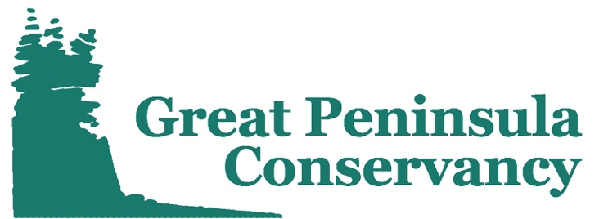
Celebrating 20 years of protecting our lands and waters

Position Title: Land Labs Education Coordinator VISTA
Organization: Great Peninsula Conservancy
Program: Great Peninsula Conservancy Land Labs
Service Location: Bremerton, Washington
Timeline for Service: August 29th, 2022 – August 28th, 2023

Teaser
Great Peninsula Conservancy seeks an environmental educator with creative vision. Design outdoor education that supports conservation, stewardship, and community engagement in west Puget Sound!

Program Description:
Great Peninsula Conservancy (GPC) is a 501(c)(3) nonprofit land trust dedicated to protecting the natural habitats, rural landscapes, and open spaces of the Great Peninsula region of west Puget Sound, Washington. GPC’s important work is accomplished through conservation, stewardship, and community engagement.
The Great Peninsula Conservancy (GPC) Land Labs program utilizes local protected lands to enhance the quality of Science, Technology, Engineering, and Math (STEM) education local schools. Hands-on science projects support the vision of the Washington State Environmental and Sustainability Literacy Plan and meet the requirements of Washington State Science and Learning Standards (WSSLS). The program engages students directly in big picture environmental concerns affecting their local communities, and opens students’ eyes to professional opportunities in the environmental science field. The Land Labs program will help prepare students from low-income families and underachieving schools for success in post-secondary education and careers in STEM.

Member Duties:
The Land Labs Education Coordinator VISTA will play an integral role in the design and development of education opportunities for Great Peninsula Conservancy and the Land Labs program. The VISTA member will write standards-based curriculum; foster relationships with schools, community members, and stakeholders; train outdoor educators; and ground-truth lessons for the Land Labs program. Under the guidance of the Programs Manager, the Education Coordinator VISTA will create education and outreach opportunities that are consistent with GPC’s identity as a community-oriented conservation authority and reflect GPC’s values of engagement, responsiveness, partnership, and respect. The VISTA member’s work will enhance and support GPC’s Diversity, Equity, and Inclusivity Commitment and the important work of making the outdoors a safe and inclusive space for all.

Primary Responsibilities:
- Design Land Labs curriculum that aligns with Washington State Science Learning Standards;
- Build sustainable relationships with local schools and community partners;
- Design and implement educator training workshops;
- Organize education and outreach opportunities for GPC members;
- Collaborate with a diverse team;
- Ground-truth, enhance, and expand the Land Labs program;
- Increase the organizational capacity of Great Peninsula Conservancy.

Qualifications:
- Passion for Great Peninsula Conservancy’s mission and vision;
- Strong writing skills;
- Strong communication skills;
- Strong organizational skills;
- High degree of initiative and spirit of service;
- Preferred: strong understanding of education standards and curriculum development;
- Preferred: experience working in outdoor environments;
- Preferred: experience teaching adult and/or youth learners;
- Preferred: valid driver’s license and personal vehicle.

AmeriCorps VISTA:
This Great Peninsula Conservancy (GPC) VISTA position is funded by the Corporations for National and Community Service and will serve within the AmeriCorps VISTA program. AmeriCorps VISTA is the national service program designed specifically to fight poverty. Each VISTA member makes a year-long, full-time commitment to serve on a specific project at a nonprofit organization or public agency. To learn more about the AmeriCorps programs visit americorps.gov.

Compensation:
In return for their service, AmeriCorps VISTA members receive a modest living allowance of $1,282/month, health benefits during their service, and have the option of receiving an AmeriCorps Education Award of $6,195 or post-service stipend of $1,800 after completing their service. A relocation travel and settling-in allowance may also apply if they are moving.

To Apply:
Send a cover letter and resume to Claire Voris (claire@greatpeninsula.org). Applications are also accepted through AmeriCorps.gov, but will require that the applicant follow up with a cover letter and resume prior to receiving an interview. Deadline for applications is July 22nd, 2022. For more information, visit Great Peninsula Conservancy’s website (greatpeninsula.org).

