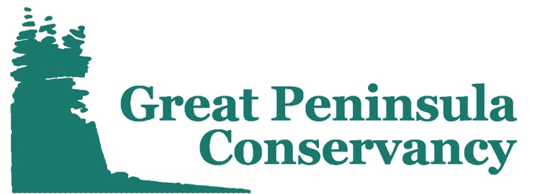
Celebrating 20 years of protecting our lands and waters

Position Title: Community Stewardship Coordinator VISTA
Organization: Great Peninsula Conservancy
Program: Great Peninsula Conservancy Land Labs
Service Location: Bremerton, Washington
Timeline for Service: August 29th, 2022 – August 28th, 2023

Teaser:
Great Peninsula Conservancy’s Land Labs program seeks a passionate environmental steward to help us make the outdoors a more inclusive space for all! Design volunteer opportunities that support conservation, stewardship, and outdoor education in west Puget Sound!

Program Description:
Great Peninsula Conservancy (GPC) is a 501(c)(3) nonprofit land trust dedicated to protecting the natural habitats, rural landscapes, and open spaces of the Great Peninsula region of west Puget Sound, Washington. GPC’s important work is accomplished through conservation, stewardship, and community engagement.

The Great Peninsula Conservancy (GPC) Land Labs program utilizes local protected lands to enhance the quality of Science, Technology, Engineering, and Math (STEM) education local schools. Hands-on science projects support the vision of the Washington State Environmental and Sustainability Literacy Plan and meet the requirements of Washington State Science and Learning Standards (WSSLS). The program engages students directly in big picture environmental concerns affecting their local communities, and open students’ eyes to professional opportunities in the environmental science field. The Land Labs program will help prepare students from low-income families and underachieving schools for success in post-secondary education and careers in STEM.

Member Duties:
The Community Stewardship Coordinator VISTA will create volunteer stewardship and youth engagement opportunities that support Great Peninsula Conservancy and the Land Labs program. The VISTA member will prepare GPC preserves for Land Labs field experiences; design opportunities for students to participate in community science and stewardship; and assist in ground-truthing Land Labs’ growing library of outdoor education lessons. Under the guidance of the Stewardship Manager, the VISTA member will also assist in improving volunteer management procedures; designing and implementing habitat restoration projects; monitoring preserves and conservation easements; and activating preserves for community science and public enjoyment. The VISTA member’s work will enhance and support GPC’s Diversity, Equity, and Inclusivity Commitment and the important work of making the outdoors a safe and inclusive space for all.

Primary Responsibilities:

- Design, organize, and manage volunteer stewardship activities related to habitat restoration, community science, and youth education;
- Develop volunteer management systems that ensure the sustainability of GPC programs;
- Promote engagement opportunities through GPC’s social media, website, and e-news;
- Build sustainable relationships with non-traditional conservation partners;
- Collaborate with a diverse team;
- Ground-truth, enhance, and expand the Land Labs program;
- Increase the organizational capacity of Great Peninsula Conservancy.

Qualifications:

- Passion for Great Peninsula Conservancy’s mission and vision;
- Exceptional verbal communication skills;
- Strong writing and organizational skills;
- Ability to multi-task in a fast-paced environment
- High degree of initiative and spirit of service;
- Preferred: experience working in outdoor environments and using tools;
- Preferred: experience in volunteer management and recruitment;
- Preferred: experience in outreach and education;
- Preferred: valid driver’s license and personal vehicle.

AmeriCorps VISTA:
This Great Peninsula Conservancy (GPC) VISTA position is funded by the Corporations for National and Community Service and will serve within the AmeriCorps VISTA program. AmeriCorps VISTA is the national service program designed specifically to fight poverty. Each VISTA member makes a year-long, full-time commitment to serve on a specific project at a nonprofit organization or public agency. To learn more about the AmeriCorps programs visit americorps.gov.

Compensation:
In return for their service, AmeriCorps VISTA members receive a modest living allowance of $1,282/month, health benefits during their service, and have the option of receiving an AmeriCorps Education Award of $6,195 or post-service stipend of $1,800 after completing their service. A relocation travel and settling-in allowance may also apply if they are moving.

To Apply:
Send a cover letter and resume to Claire Voris (claire@greatpeninsula.org). Applications are also accepted through AmeriCorps.gov, but will require that the applicant follow up with a cover letter and resume prior to receiving an interview. Deadline for applications is July 22nd, 2022. For more information, visit Great Peninsula Conservancy’s website (greatpeninsula.org).

